**CA3001 – Programming and Data Structure using C**

**Assignment: 4 (29.12.2020)**

**Q1**. Check Whether a Character is a Vowel or Consonant (Using if)

Ans – C Program & Output:

#include <stdio.h>

int main()

{

char ch;

printf("Input any alphabet : ");

scanf("%c", &ch);

if(ch=='a' || ch=='e' || ch=='i' || ch=='o' || ch=='u' || ch=='A' || ch=='E'|| ch=='I' || ch=='O' || ch=='U')

printf("The alphabet is a vowel\n");

else

printf("The alphabet is a consonant");

return 0;

}

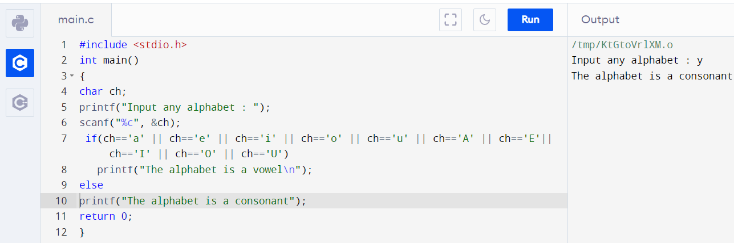

**Q2**. Find Roots of a Quadratic Equation(Using else if ladder)

Ans – C Program & Output:

#include<stdio.h>

#include<math.h>

int main()

{

int a,b,c,d;

float x1,x2;

printf("Input the value of a,b & c : ");

scanf("%d%d%d",&a,&b,&c);

d=b*b-4*a*c;

if(d==0)

{

printf("Both roots are equal.\n");

x1=-b/(2.0*a);

x2=x1;

printf("First Root Root1= %f\n",x1);

printf("Second Root Root2= %f\n",x2);

}

else if(d>0)

{

printf("Both roots are real and diff-2\n");

x1=(-b+sqrt(d))/(2*a);

x2=(-b-sqrt(d))/(2*a);

printf("First Root Root1= %f\n",x1);

printf("Second Root root2= %f\n",x2);

}

else

printf("Root are imeainary;\nNo Solution. \n");

return 0;

}

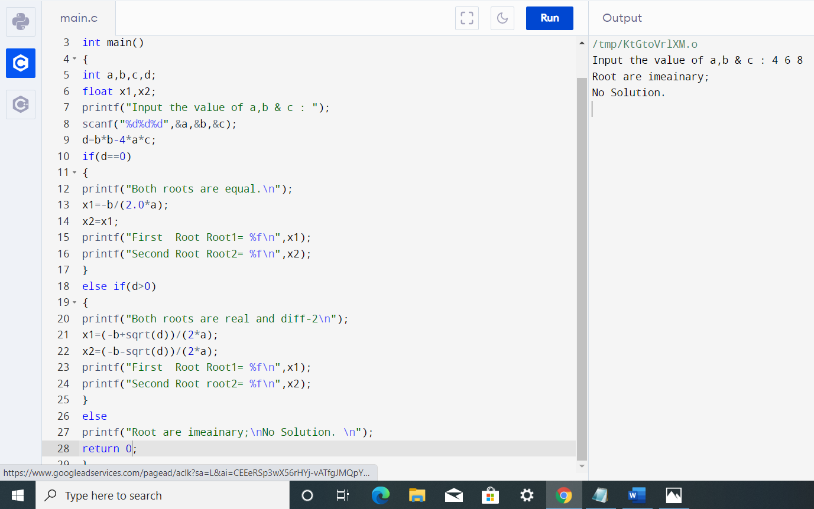

**Q3**. Check Leap Year (Using if..else)

Ans – C Program & Output:

#include <stdio.h>

int main()

{

int year;

printf("Enter the year:");

scanf("%d",&year);

if ((year % 4 == 0) && (year % 100!= 0))

printf("%d is a leap year", year);

else

printf("%d is not a leap year", year);

return 0;

}

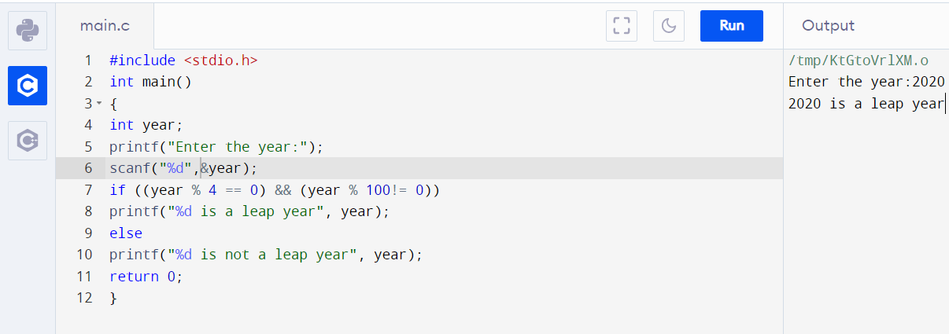

**Q4.** Check which number nearest to the value 100 among two given integers. Return 0 if the two numbers are equal. (Using nested if...else)

Ans – C Program & Output:

#include <stdio.h>

int main()

{

int a,b,n1,n2;

printf("enter two numbers:\n");

scanf("%d%d",&a,&b);

n1=100-a;

n2=100-b;

if(n1<=n2)

{

if(n1==n2)

{

printf("both the numbers are nearest to 100 \n %d",(n1==n2)?0:1);

}

else{

printf("the number nearest to 100 is:%d",a);

}

}

else

{

printf("the number nearest to 100 is:%d",b);

}

return 0;

}

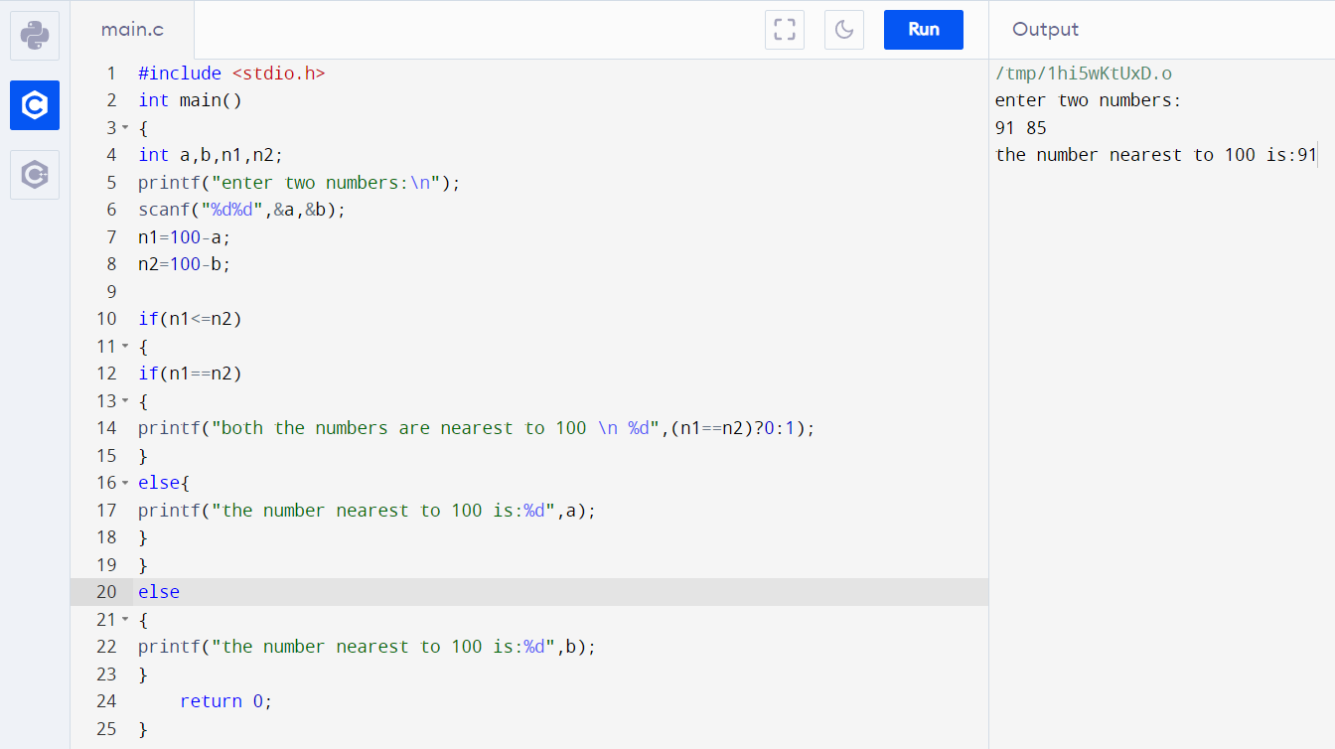

**Q5**. Check three given integers (small, medium and large) and return true if the difference between small and medium and the difference between medium and large is same. (Using nested if...else)

Ans – C Program & Output:

#include<stdio.h>

int main()

{

int a,b,c;

printf("enter three numbers:\n");

scanf("%d%d%d",&a,&b,&c);

if(a>=b && a>=c)

{

if(b>c)

{

printf(" the value for medium (%d)-small(%d)==large(%d)-medium(%d) is: %d",b,c,a,b, b-c==a-b);

}

else

{

printf(" the value for medium (%d)-small(%d)==large(%d)-medium(%d) is: %d",c,b,a,c, c-b==a-c);

}

}

if(b>=a && b>=c)

{

if(a>c)

{

printf(" the value for medium (%d)-small(%d)==large(%d)-medium(%d) is: t%d",a,c,b,a, a-c==b-a);

}

else

{

printf(" the value for medium (%d)-small(%d)==large(%d)-medium(%d) is: %d ",c,a,b,c, c-a==b-c);

}

}

if(c>=b && c>=a)

{

if(a>b)

{

printf(" the value for medium (%d)-small(%d)==large(%d)-medium(%d) is: %d ",a,b,c,a, a-b==c-a);

}

else{

printf(" the value for medium (%d)-small(%d)==large(%d)-medium(%d) is: %d",b,a,c,b, b-a==c-b);

}

}

return 0;

}

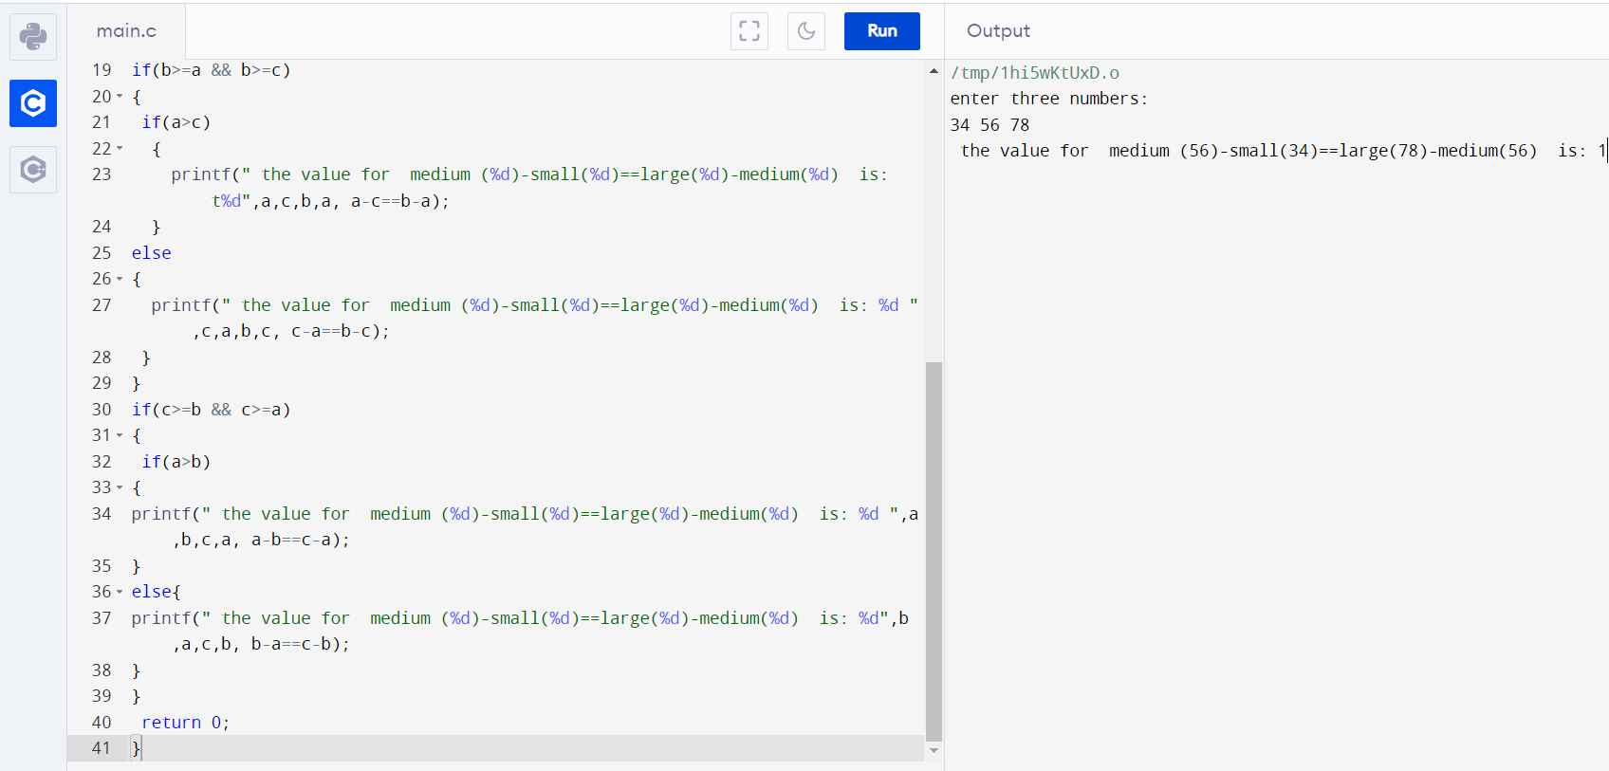

**Q6**. Write a program in C to calculate and print the Electricity bill of a given customer. The customer id., name and unit consumed by the user should be taken from the keyboard and display the total amount to pay to the customer. The charge are as follows:

|  |  |
| --- | --- |
| **Unit** | **Charge/unit** |
| upto 199 | @1.20 |
| 200 and above but less than 400 | @1.50 |
| 400 and above but less than 600 | @1.80 |
| 600 and above | @2.00 |

If the bill exceeds Rs. 400 then a surcharge of 15% will be charged and the minimum bill should be of Rs. 1

Ans: C Program & Output:

#include <stdio.h>

#include <string.h>

int main()

{

int customer_id, n;

float charge, surcharge=0, amt,netamt;

char consumer[25];

printf("Input Customer ID :");

scanf("%d",&customer_id);

printf("Input the name of the customer :");

scanf("%s",consumer);

printf("Input the unit consumed by the customer : ");

scanf("%d",&n);

if (n<200 )

charge = 1.20;

else if(n>=200 && n<400)

charge = 1.50;

else if (n>=400 && n<600)

charge = 1.80;

else

charge = 2.00;

amt = n*charge;

if (amt>300)

surcharge = amt*15/100.0;

netamt = amt+surcharge;

if (netamt < 100)

netamt =100;

printf("\nElectricity Bill\n");

printf("Customer IDNO :%d\n",customer_id);

printf("Customer Name :%s\n",consumer);

printf("unit Consumed :%d\n",n);

printf("Amount Charges @Rs. %4.2f per unit :%8.2f\n",charge,amt);

printf("Surchage Amount :%8.2f\n",surcharge);

printf("Net Amount Paid By the Customer :%8.2f\n",netamt);

return 0;

}

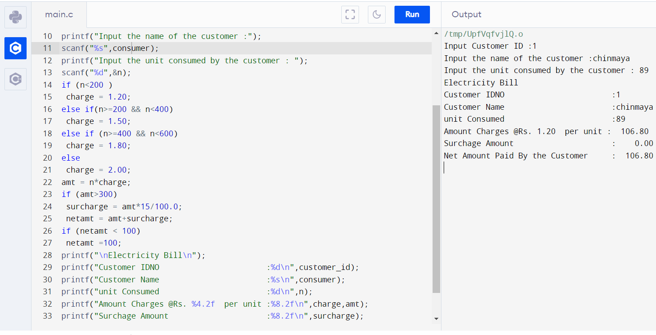

**Q7**. The marks obtained by a student in 3 different subjects are input by the user. Your program should calculate the average of subjects and display the grade. The student gets a grade as per the following rules:

|  |  |
| --- | --- |
| **Average** | **Grade** |
| 90-100 | A |
| 80-89 | B |
| 70-79 | C |
| 60-69 | D |
| 0-59 | F |

Ans – C Program & Output:

#include <stdio.h>

int main()

{

int marks1, marks2, marks3, average;

printf("Enter marks obtained in subject 1 :");

scanf("%d", &marks1);

printf("Enter marks obtained in subject 2 :");

scanf("%d", &marks2);

printf("Enter marks obtained in subject 3 :");

scanf("%d", &marks3);

average = (marks1 + marks2 + marks3) / 3;

printf("Average : %d\n", average);

if (average >= 90)

{

printf("Grade A");

}

else if (average >= 80)

{

printf("Grade B");

}

else if (average >= 70)

{

printf("Grade C");

}

else if (average >= 60)

{

printf("Grade D");

}

else

{

printf("Grade F");

}

return 0;

}

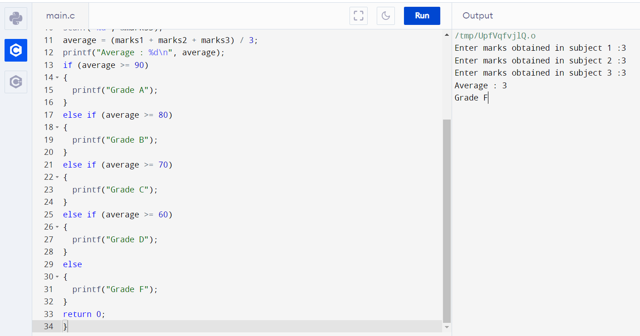

**Q8.** Print total number of days in a month using switch case

Ans – C Program & Output:

#include <stdio.h>

int main()

{

int month;

printf("Enter month number(1-12): ");

scanf("%d", &month);

switch(month)

{

case 1:

printf("31 days");

break;

case 2:

printf("28/29 days");

break;

case 3:

printf("31 days");

break;

case 4:

printf("30 days");

break;

case 5:

printf("31 days");

break;

case 6:

printf("30 days");

break;

case 7:

printf("31 days");

break;

case 8:

printf("31 days");

break;

case 9:

printf("30 days");

break;

case 10:

printf("31 days");

break;

case 11:

printf("30 days");

break;

case 12:

printf("31 days");

break;

default:

printf("Invalid input! Please enter month number between 1-12");

}

return 0;

}

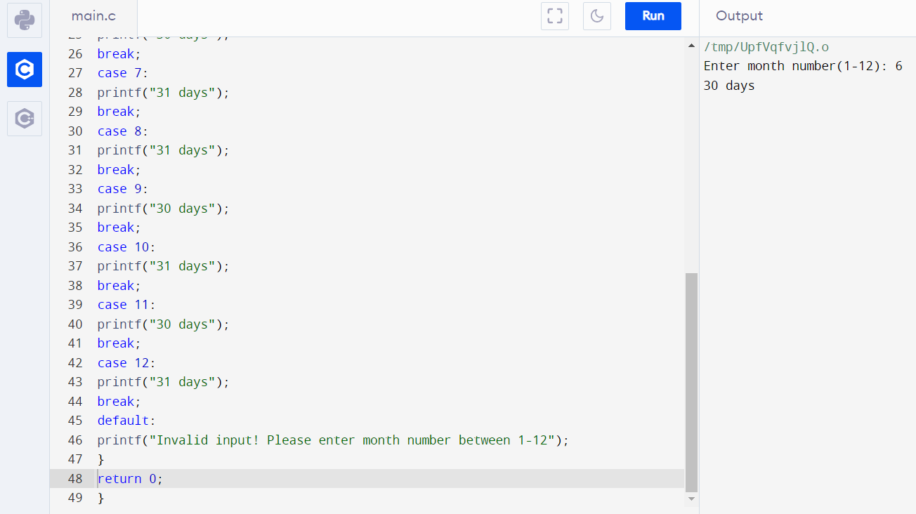

**Q9.** Create Simple Calculator using switch case

Ans – C program & Output:

#include <stdio.h>

int main() {

char operator;

int first, second;

printf("Enter an operator (+, -, *, / ): ");

scanf("%c", &operator);

printf("Enter two operands: ");

scanf("%d %d", &first, &second);

switch (operator) {

case '+':

printf("%d + %d = %d", first, second, first + second);

break;

case '-':

printf("%d - %d = %d", first, second, first - second);

break;

case '*':

printf("%d * %d = %d", first, second, first * second);

break;

case '/':

printf("%d / %d = %d", first, second, first / second);

break;

default:

printf("Error! operator is not correct");

}

return 0;

}

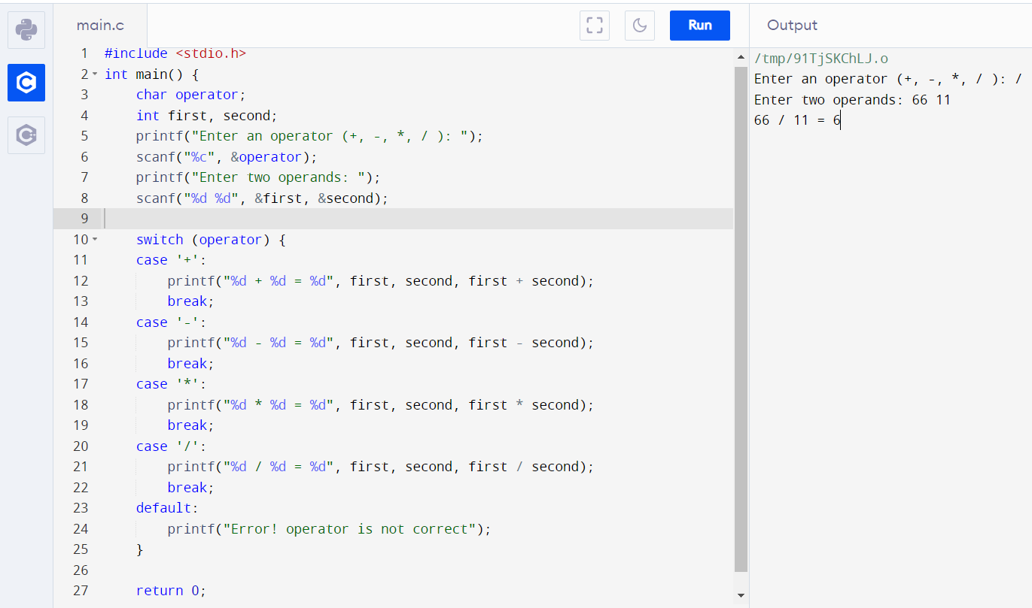

Q10. Prompts the user to enter grade. Your program should display the corresponding meaning of grade as per the following table(Using Switch Case)

|  |  |
| --- | --- |
| **Grade** | **Meaning** |
| A | Excellent |
| B | Good |
| C | Average |
| D | Deficient |
| F | Failing |

#include<stdio.h>

int main()

{

char grade;

printf("Enter grade (A, B, C, D, F):\n");

scanf("%c",&grade);

switch(grade)

{

case 'A':

printf("Meaning : Excellent");

break;

case 'B':

printf("Meaning : Good");

break;

case 'C':

printf("Meaning : Average");

break;

case 'D':

printf("Meaning : Deficient");

break;

case 'F':

printf("Meaning : Failing");

break;

default:

printf("The grade is not correct");

break;

}

}

